A MINI PROJECT REPORT

ON

“OLYMPyCS”

Submitted to

SAVITRIBAI PHULE PUNE UNIVERSITY

in completion of
SKILL DEVELOPMENT LABORATORY
(T.E Computer Engineering)

BY

Name of the student: Aniruddh Bhagwat Exam No :
Name of the student: Akash Kumar Exam No :
Name of the student: Vaibhav Kumar Exam No :



Department of Computer Engineering
Sinhgad College of Engineering, Pune-41
Accredited by NAAC with grade ‘A’

YEAR 2019 - 20

CERTIFICATE

Sinhgad Technical Education Society,
Department of Computer Engineering
Sinhgad College of Engineering, Pune-41
Accredited by NAAC with grade ‘A’

“OLYMPyCS”

Submitted to

SAVITRIBAI PHULE PUNE UNIVERSITY

in completion of

SKILL DEVELOPMENT LABORATORY
(T.E Computer Engineering)

BY

Name of the student: Aniruddh Bhagwat Exam No :
Name of the student: Akash Kumar Exam No :
Name of the student: Vaibhav Kumar Exam No :

Prof. Prof. M. P. Wankhade
Internal Guide Head of Dept.
Department of Computer Engineering Department of Computer Engineering

Dr. S.D. Lokhande
Principal
SCOE, Pune

CONTENTS

TITLE PAGE NO

Certificate I
Acknowledgement II
Abstract III

- INTRODUCTION

  - Background And Basics
  - Problem Statement

2. PROJECT PLANNING & MANAGEMENT
  - Software and Hardware requirement
  - Process Model

3. ANALYSIS & DESIGN
3.1 Use-Case Diagrams
3.2 Class Diagrams
3.3 ER Diagrams(if applicable)

4. IMPLEMENTION & CODING
  - Methodology
  - Database schema
4.3 Algorithms
4.4 Machine learning algorithms

5. RESULTS & DISCUSSION
4.1 Visualization of results (Graphs, Charts, etc.)

6. CONCLUSION

REFERENCES

- Book

- Eric Matthes, Python Crash Course, 2016 Edition, No starch press, 2016 .

  - World Wide Web

    - Kaggle , https://www.kaggle.com/heesoo37/120-years-of-olympic-history-athletes-and-results/kernels

    - Geeks for geeks, https://www.geeksforgeeks.org

    - Google, https://www.google.com

    - Make a web app using python and Flask , https://aryaboudaie.com/python/technical/educational/web/flask/2018/10/17/flask.html

    - Passing plots to web page ,https://galaxydatatech.com/2018/04/01/passing-plots-web-page/

    - Quick start Flask documentation , https://flask.palletsprojects.com/en/1.1.x/quickstart/#accessing-request-data

ACKNOWLEDGEMENT

I take this opportunity to express my profound gratitude and deep regards to my guide Prof. Girija Chiddarwar for his exemplary guidance, monitoring and constant encouragement throughout the course of this thesis. The blessing, help and guidance given by him time to time shall carry me a long way in the journey of life on which I am about to embark.

I am obliged to staff members of SCOE for the valuable information provided by them in their respective fields. I am grateful for their cooperation during the period of my assignment.

Lastly, I thank almighty, my parents, brother, sisters and friends for their constant encouragement without which this project would not be possible.

ABSTRACT

In this project, We are going to do an in-depth analysis of Olympics data from Athens 1896 to Rio 2016.This analysis includes checking the performance of countries on the basis of different sports they have played, the year in which they got the maximum medal count. We will also be comparing performance of two countries over the year and also in a particular year. Also describing the best players of the sport.

Using machine learning (Supervised), we are going to use different algorithms to predict gender of the player and medal count for any country depending on the count of players participating for that year.

INTRODUCTION

  - BACKGROUND AND BASICS

The need for initiating the project is –
- To have basic idea about performance of different countries throughout the Olympics.
- To visualize performance of different countries in a particular sport.
- To determine the sport in which a country performs the best.
- To determine the most successful year of a country.
- To check if there is any relation between medal count of the country and players participated during a particular year.

After successful completion of above needs, we will have better idea about the performance of various countries in the Olympics. We can also use this knowledge to predict their performance in future Olympics.

  - PROBLEM STATEMENT

We are using the dataset of Olympics from 1896 – 2016 to determine the following -
- Analysis country’s performance based on a particular sport .
- Comparison between two countries .
- Determining the best year of the country on the basis of medals earned .
- Determine the top players for a particular sport .
- Using the machine learning algorithms to perform gender prediction and medal count prediction.

PROJECT PLANNING & MANAGEMENT

2.1. HARDWARE AND SOFTWARE REQUIREMENTS

- Python Version 2.7.x or above .
- Operating system : Windows 7 and Later, Linux , MacOS .
- A good integrated development environment(IDE) .
- Following python libraries –
- Pickle
- Flask
- Numpy
- Pandas
- Matplotlib
- Sklearn
- Seaborn

2.2. PROCESS MODEL

We have used waterfall model to complete the following project.

First, Requirement analysis and system design was done that includes discussion about objective of the project and hardware & software requirements. This also including planning about the flow of control in the project.

Implementation was carried out which includes development of smaller modules that is required to solve a part of software and then these modules were linked together to get the final project.

Testing was carried to check if all the objectives has been covered and dealt with properly. This also includes testing of functional and non-functional modules of the project. In case of error, the code of the particular module was rechecked and required changes was made so that it can work properly.

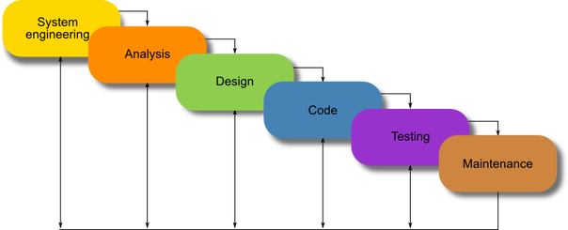

After testing phase, maintenance at regular interval was carried out at regular intervals to make the project more and more efficient and effective. This phase also includes making changes to the code if there is any changes in the requirements by the end user (if any).

ANALYSIS AND DESIGN

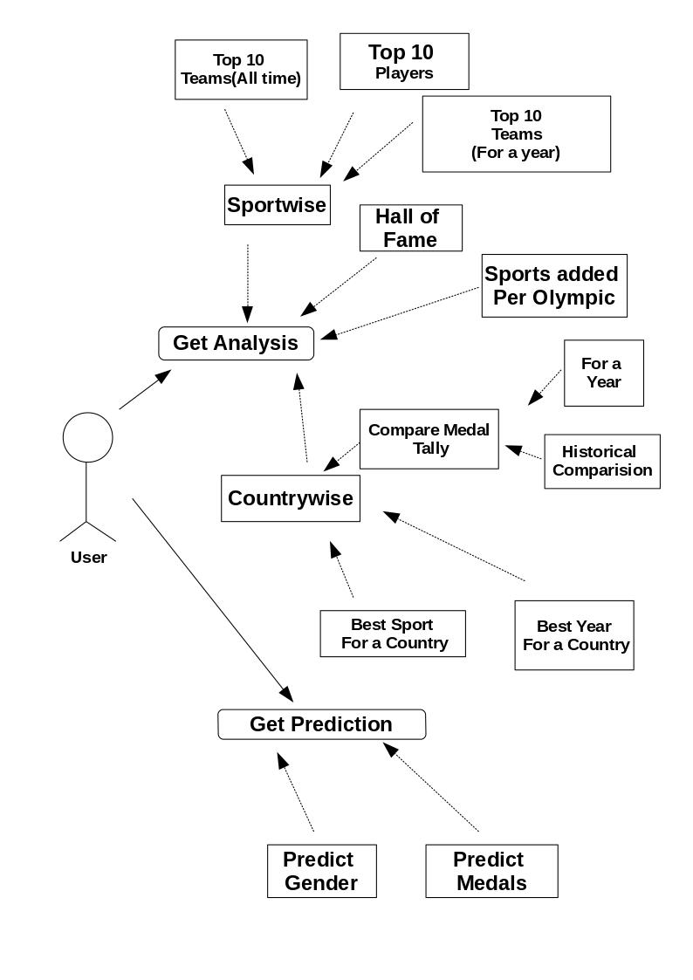
3.1. USE - CASE DIAGRAM

3.2. CLASS DIAGRAM

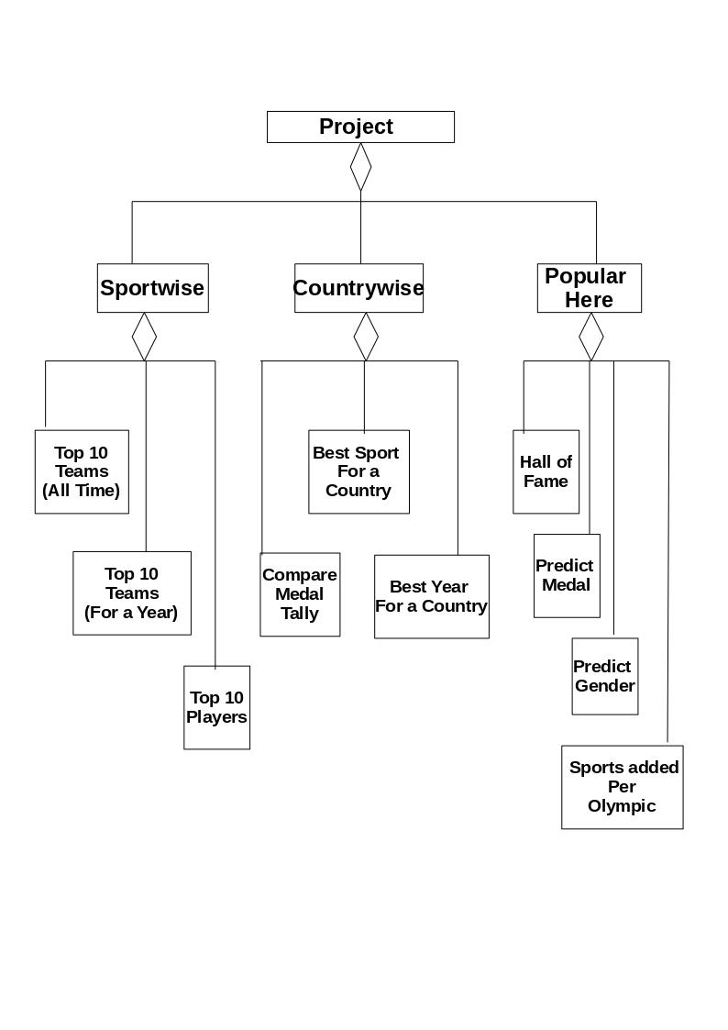

3.3. E – R DIAGRAM

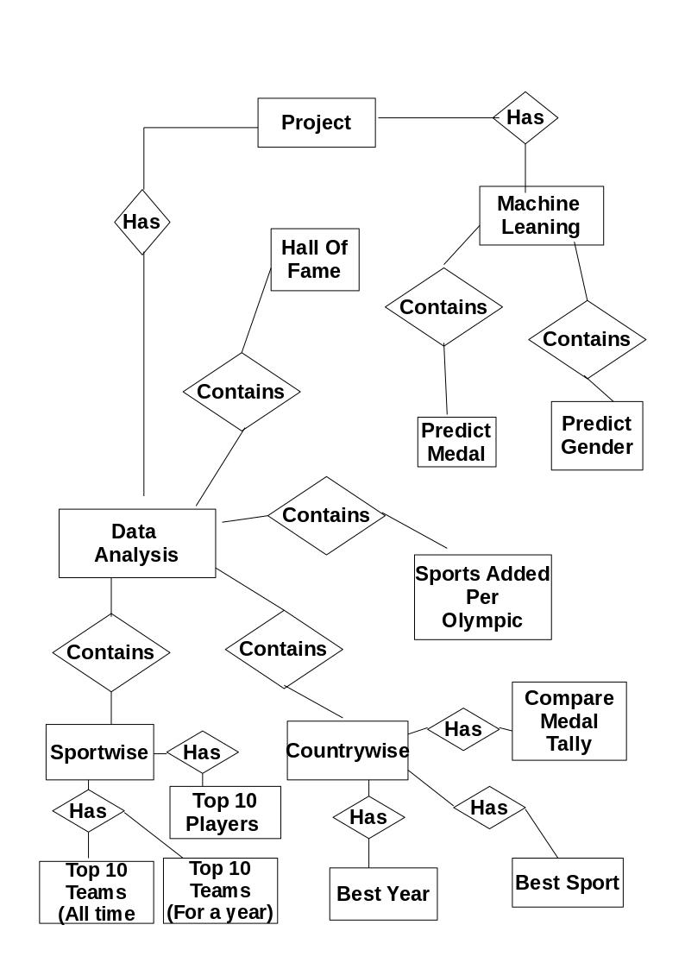

IMPLEMENTION & CODING

4.1. METHODOLOGY

In this project, we are trying to display the performance of different countries in Olympics. Further, we displayed performance of countries based on a particular sport and also in a particular year. All these helps us make some conclusion based on the results obtained.

The dataset is available online. It was collected by a group of Olympic history enthusiasts and self proclaimed ‘statisticians’. It can be readily downloaded from Kaggle.

Methods used to get the above objectives done are :
- For preparation of dataset, we used basic knowledge of python to remove missing values(NaN),removing outliers…etc.
- We used Pandas and Numpy libraries to process the data and get meaningful information.
- We further used matplotlib and seaborn library of python for better visualization of results.
- We used sklearn library for importing machine learning algorithms.

4.2. DATABASE SCHEMA

The database consists of two files – athlete_events.csv and noc_regions.csv . The file athlete_events.csv contains 271116 rows and 15 columns. Each row corresponds to an individual athlete competing in an individual Olympic event (athlete-events). The columns are:

ID - Unique number for each athlete
Name - Athlete's name
Sex - M or F
Age - Integer
Height - In centimeters
Weight - In kilograms
Team - Team name
NOC - National Olympic Committee 3-letter code
Games - Year and season

Year - Integer
Season - Summer or Winter
City - Host city
Sport - Sport
Event - Event
Medal - Gold, Silver, Bronze, or NA

4.3. ALGORITHMS

4.3.1. Analysis on the basis of sport

1. Select a sport from the list of available sports
2. For top 10 best countries performing in the above selected, we have selected those rows of data frame that contain the above selected sport.
2.1. Group the data on the basis of countries. After grouping ,the sum of all the attributes along with sorting of data based on medal count was done.
2.2. The resultant data frame was graphed using matplotlib.
3. For top 10 best countries for the above sport in a particular year, we have selected those rows of data frame that contain the above selected sport.
3.1. Group the data on the basis of countries. After grouping ,the sum of all the attributes
along with sorting of data based on medal count was done.
3.2. The resultant data frame was graphed using matplotlib.
4. For top 10 players that won the most medals in the above selected sport, we have selected those rows of data frame that contain the above selected sport.
4.1. Group the data on the basis of player name. After grouping, the sum of all the attributes along with sorting of data based on medal count was done.
4.2. The resultant data frame contains the name of top 10 players that has won the maximum number of medals in the above sport. The resultant data frame was displayed.

4.3.2. Analysis on the basis of country

- Comparison between two countries in 120 years of Olympics.
  - First, name of the country to be compared is selected from the list of countries.
  - Select only those rows in the data frame where country name is from either of the two above selected names.
  - Group the data based on the country name and year.
  - Using matplotlib’s line plot, plot the above data frame with x-axis having years and y-axis as medal count.
  - The above graph shows the comparison between performance of two countries throughout the Olympics.

- Comparison between two countries in a particular year.

  - First, name of the country to be compared is selected from the list of countries and the year in which you want to compare them.
  - Select only those rows in the data frame where country name is from either of the two above selected names.
  - Group the data based on the country name and year.
  - Select only those rows in the data frame where year is equal to selected year.
  - Using matplotlib’s bar chart, we are going to display the above resultant data frame.

- To find the sport in which a given country performs the best.

  - First, name of the country is selected from the list of countries.
  - Select only those rows in the data frame where country name is equal to selected country name.
  - Group the data based on the type of sport and sort the data based on the medal count.
  - Using matplotlib’s bar chart, we are going to display the top 10 best sport for the selected country.

4.3.3. Popular options (Machine learning & Other algorithms)

- Predicting gender of the player.

  - Take age, height and weight of player whose gender you want to predict.
  - We have assigned the feature set (X) of the prediction algorithm as data frame’s Age, Height , Weight columns.
  - And the label (y) is going to be Sex column.
  - Now, we have used sckit learn’s (sklearn) supervised algorithm DECISION TREE CLASSIFIER to predict our result.
  - The classifier is trained first using sklearn.model_selection.train_test_split() .
  - To fit the data on training data, we use DecisionTreeClassifier.fit() .
  - In the end, to predict the result DecisionTreeClassifier.predict() was used.
  - We have graphed the result using seaborn’s scatter plot and the predicted point is highlighted using green point on the graph.

- Predicting medal count .

  - Take the number of participants and name of the country as the input to determine the number of medals a selected country will win.
  - Select only those rows in which the name of the country is same as selected country.
  - Group the data on the basis of year.
  - We have assigned the feature set (X) of the prediction algorithm as data frame’s ID columns.
  - And the label (y) is going to be Medal column.
  - Now, we have used sckit learn’s (sklearn) supervised algorithm LINEAR REGRESSION to predict our result.
  - The classifier is trained first using sklearn.model_selection.train_test_split() .
  - To fit the data on training data, we use LinearRegression.fit() .
  - In the end, to predict the result LinearRegression.predict() was used.
  - The data is graphed using matplotlib’s scatter plot to known values and the regression is plotted too.

- Most accomplished athletes .

  - Group the data frame on the basis of Name, Sport and Team .
  - Sum all the attributes of the data frame and sort the data frame based on the medal count in descending order.
  - The resultant data frame will have name of players that has won maximum medal for their country. Display the resultant data frame.

- Year of introduction of a sport in Olympics .

  - Make a list of unique sport names(let slst) and a empty list for spname, and another list for fyear=[] .
  - Then, for each sport in the sportlist (slst), take another data frame(let temp) with that sport only and group that data frame (temp) by year, and sort it(temp) by year , append the iterated sport in slst to spname list.
  - Also, append the first value of year in temp to fyear list .
  - Make a new data frame from the above two list (slst and fyear), and you can give data frame’s column names as you like.
  - Then group the above data frame by year and apply a list function (because grouping gives a groupby object and apply will convert it into series and we are converting that series to data frame using .to_frame() funtion).

  - MACHINE LEARING ALGORITHMS USED

- Linear Regression

Regression is usually termed as determining relationship(s) between two or more variables.
For example, consider the variables X and Y. X as the independent variable and Y as the dependent variable and Y has a continuous range.
In case of line regression, We try to establish a line relationship between X and Y which can be represented by a straight line ( Y=mX + c).

- Decision Tree Classifier

Decision Tree Classifier, repetitively divides the working area(problem) into sub parts by identifying lines. Dividing efficiently based on maximum information gain is key to decision tree classifier.
The classifier uses a tree like structure to determine the result. The nodes of tree denotes the different possible results. And the branches denotes the decisions that needs to be taken depending on the available information.

RESULTS & DISCUSSION

5.1. VISUALISATION OF RESULT

Top 10 countries for a sport (All time) :
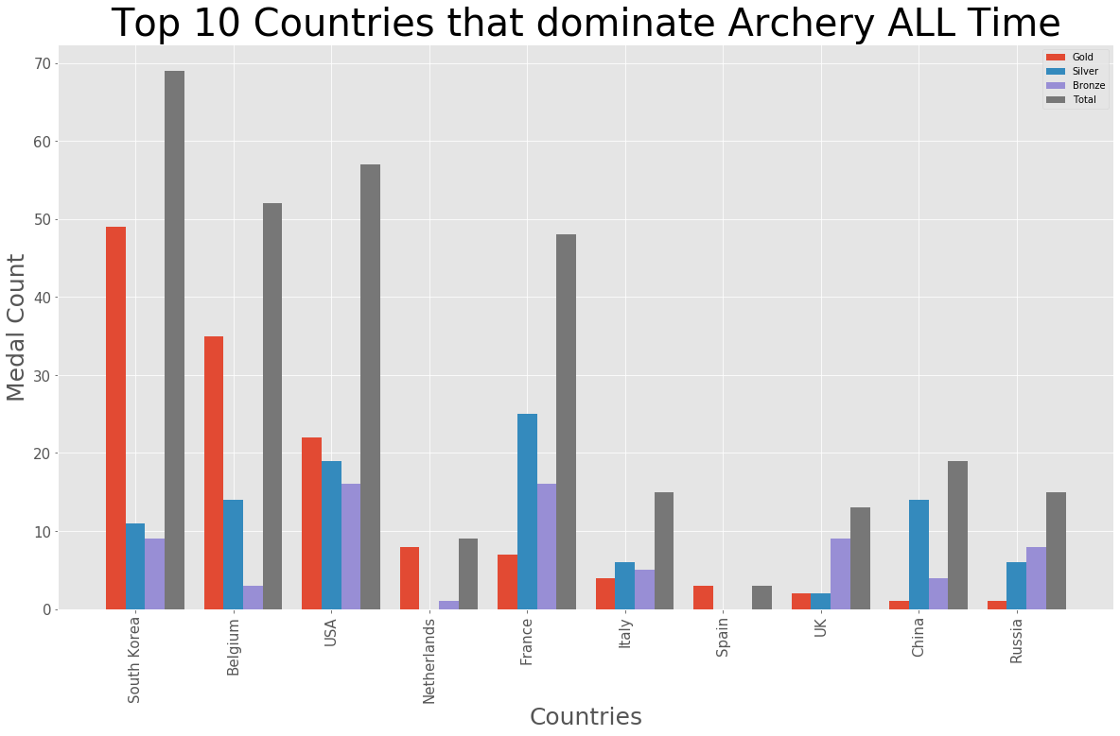

Top countries for a particular sport in a particular year :
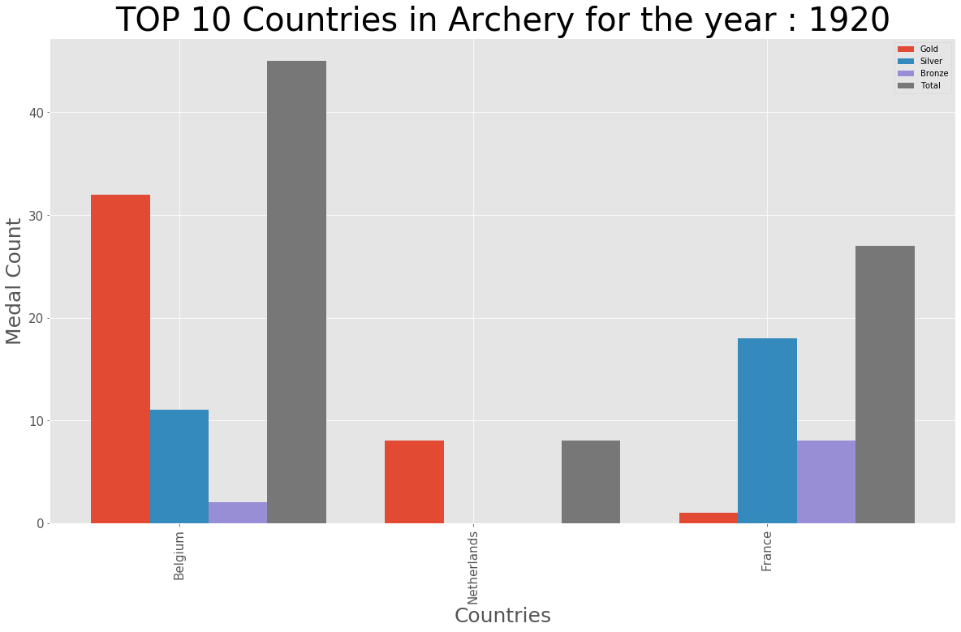

Also Medals Tally is displayed for that year:
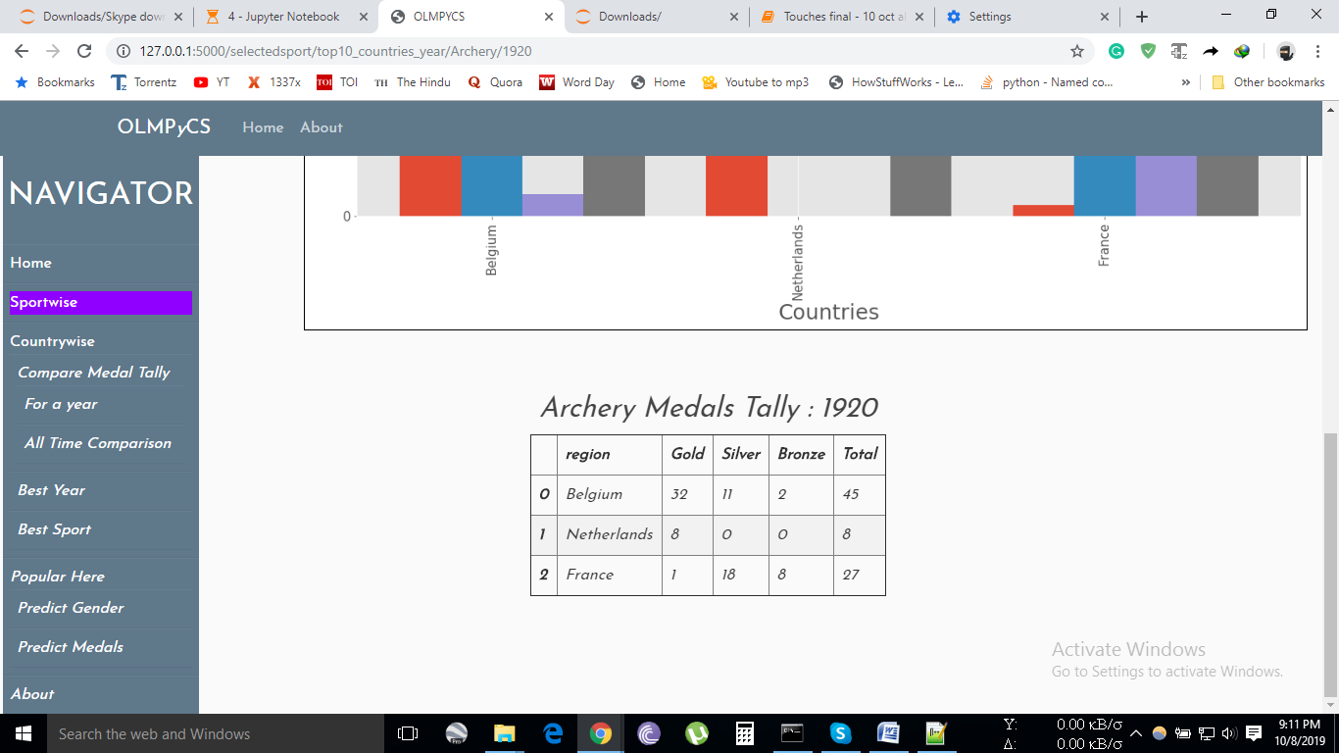

Top 10 Players for the sport :
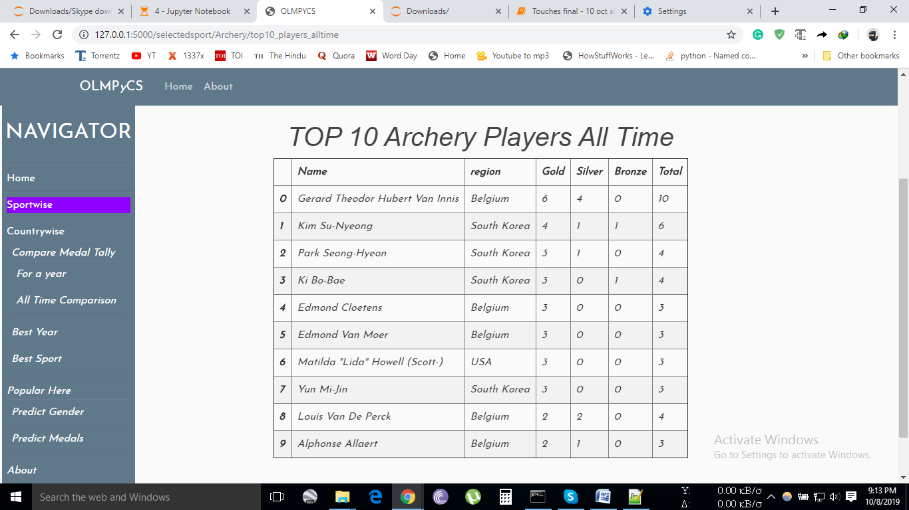

Comparison between medal tally of two countries in a particular year : 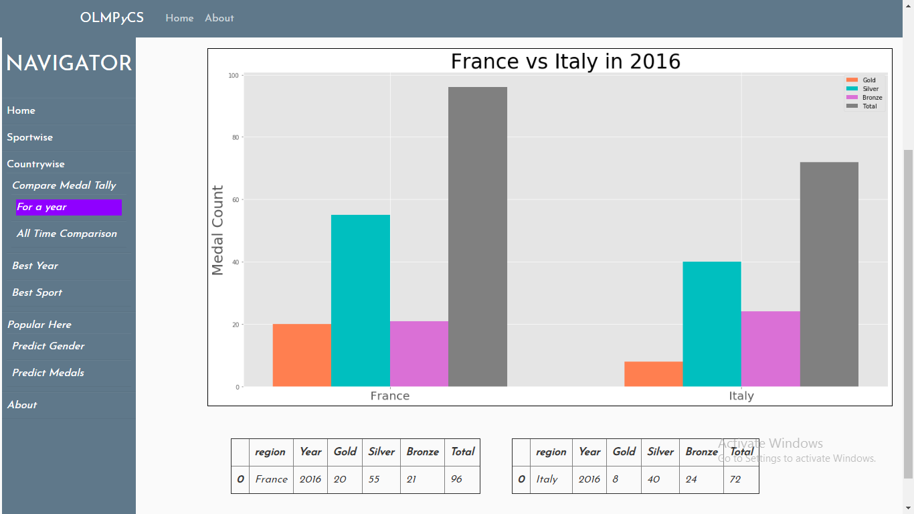

Comparison between two countries over the period of 120 years :
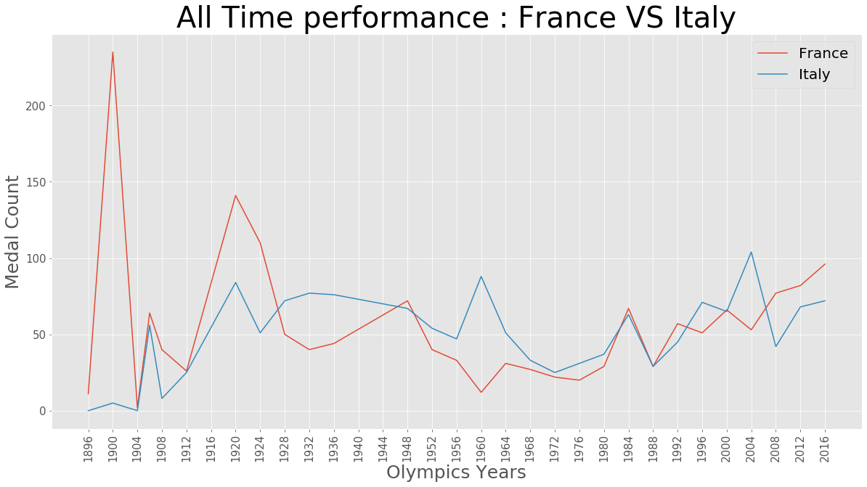

Displays the above data in tabular form too.
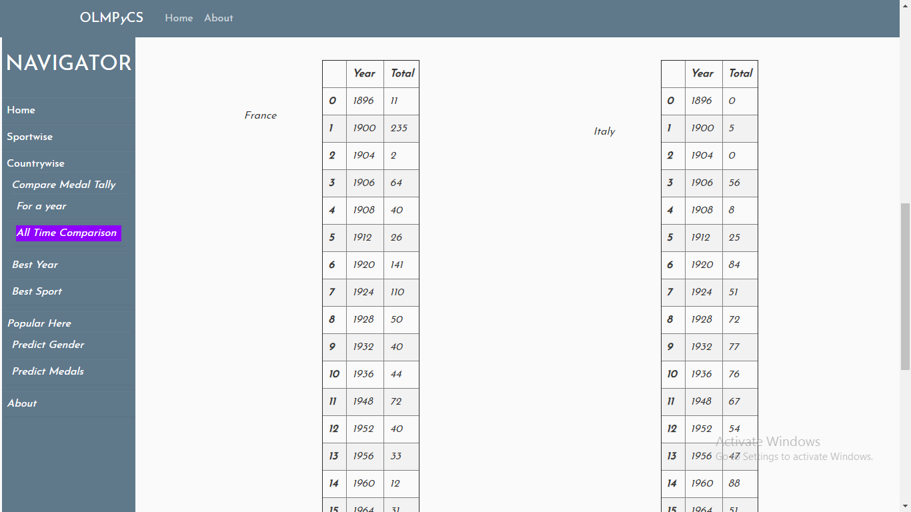
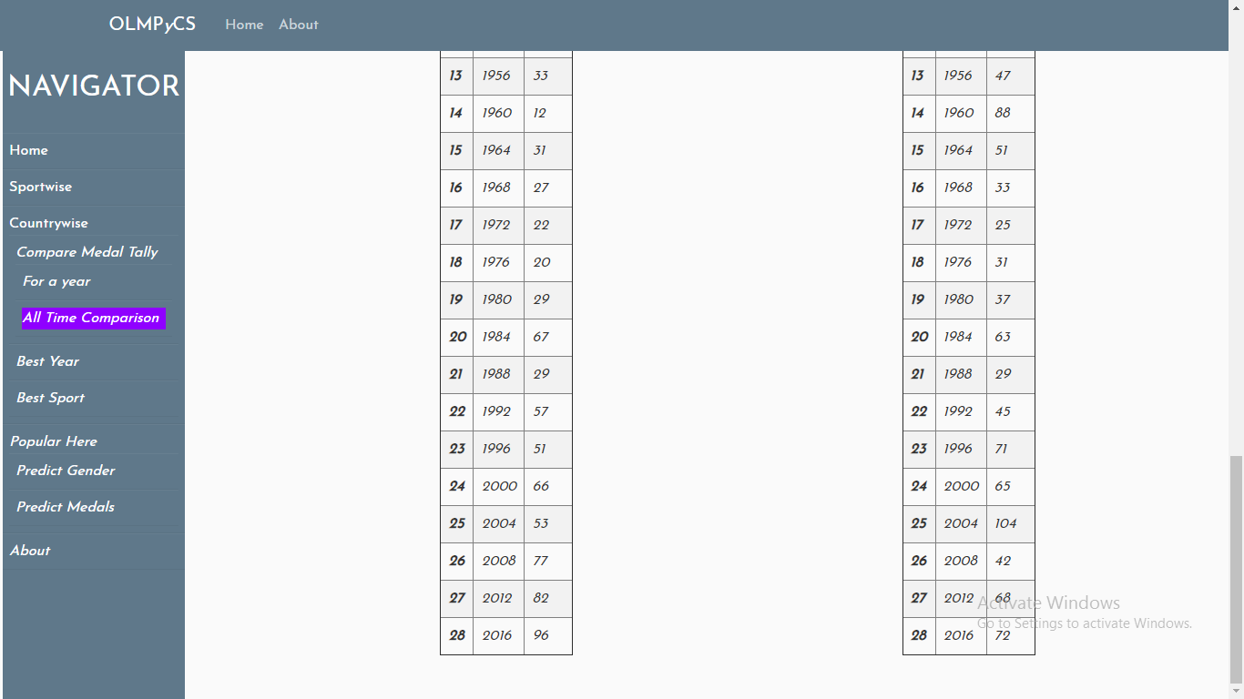

Year wise performance of a country :
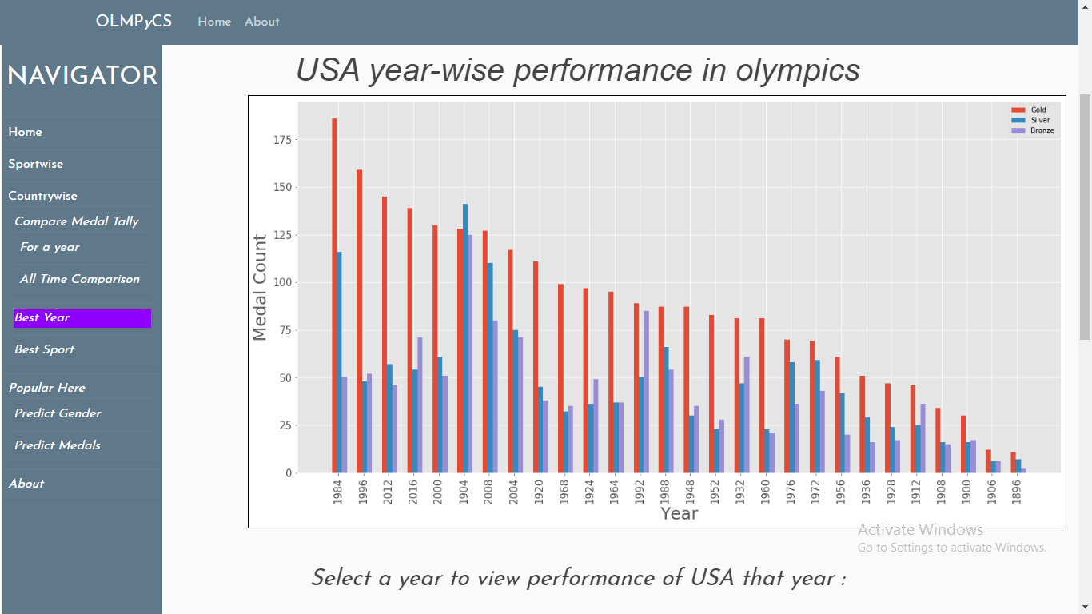

Performance of a country in a particular year 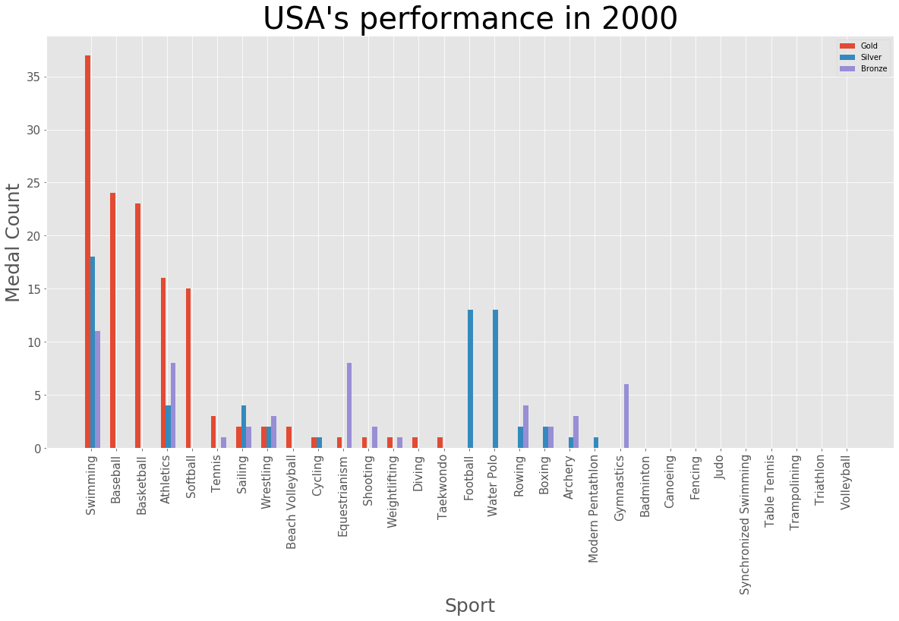

Representation of data in tabular form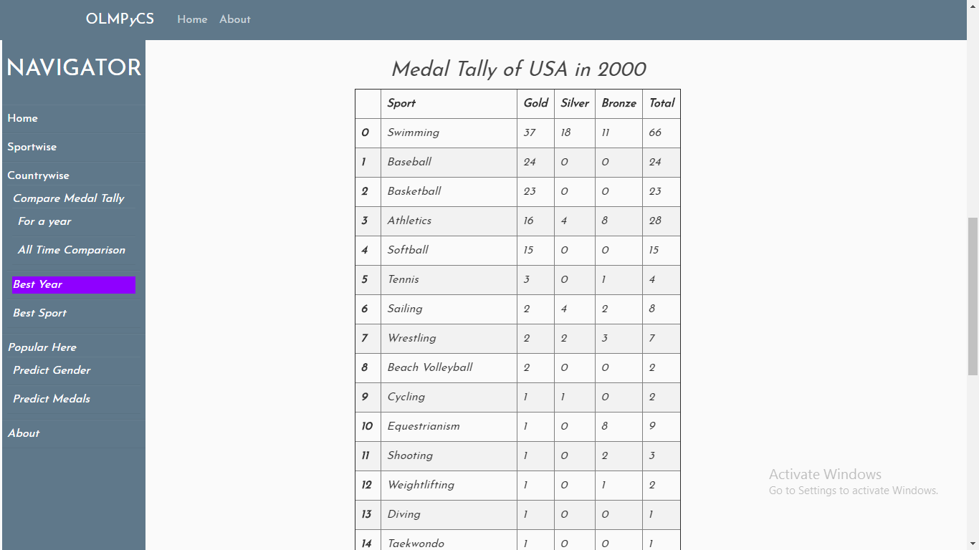 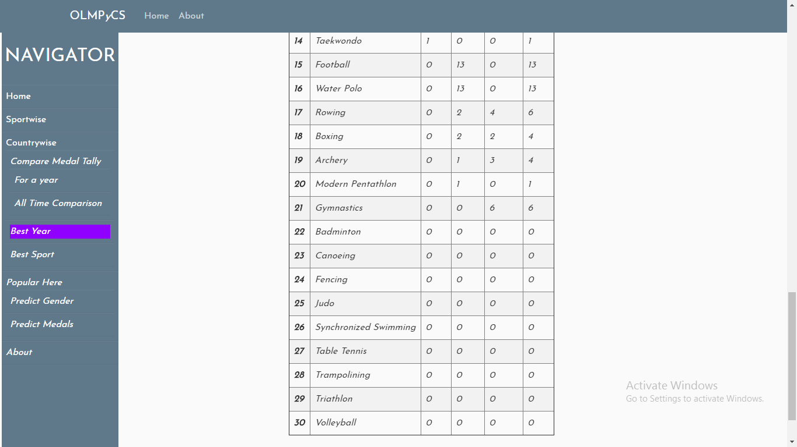

Sport that fetched the most medal for a country :
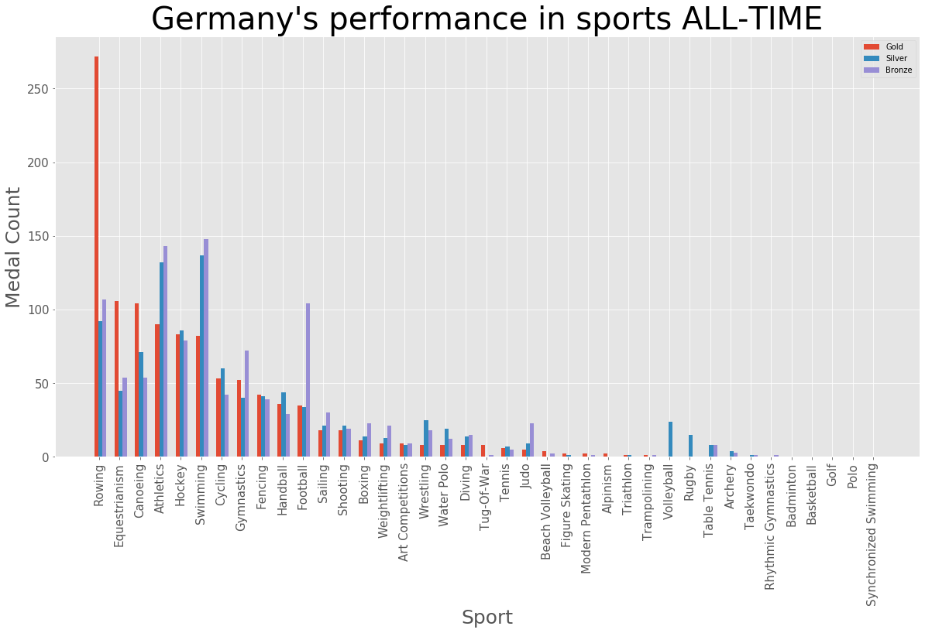

Year wise performance of the country in that particular sport :
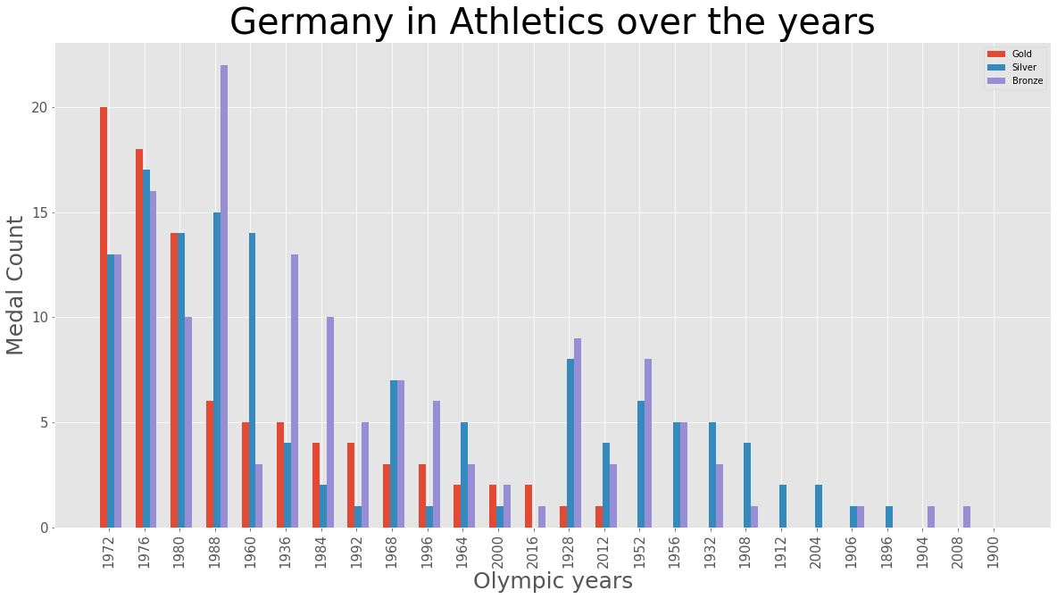

Tabular representation :
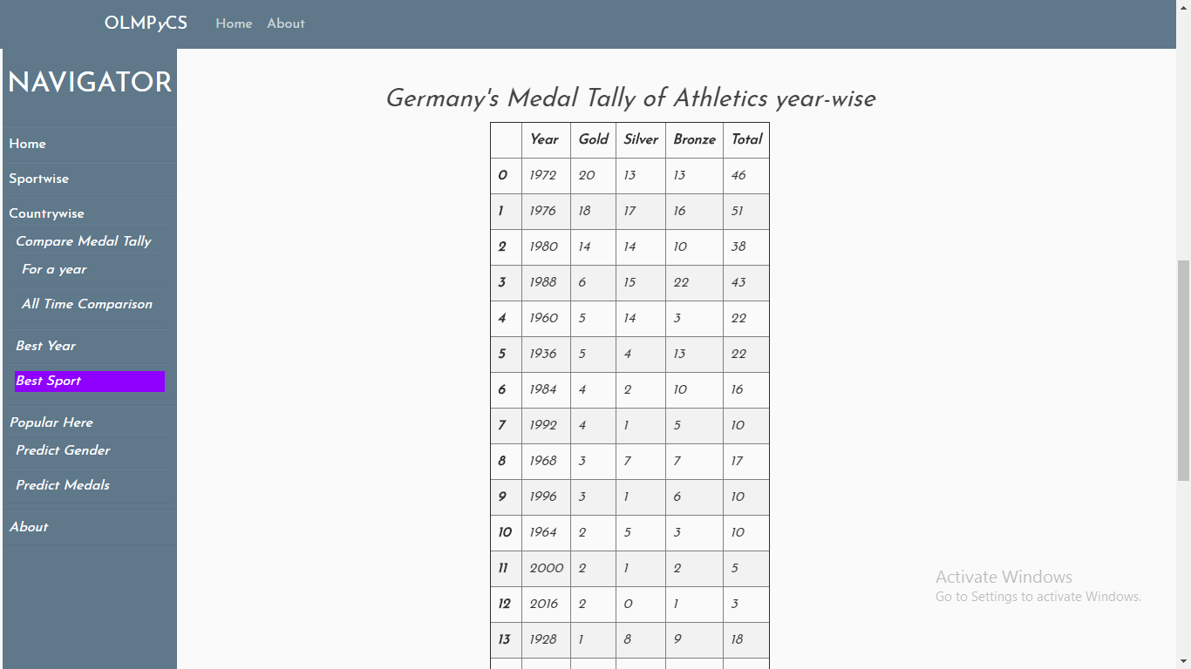
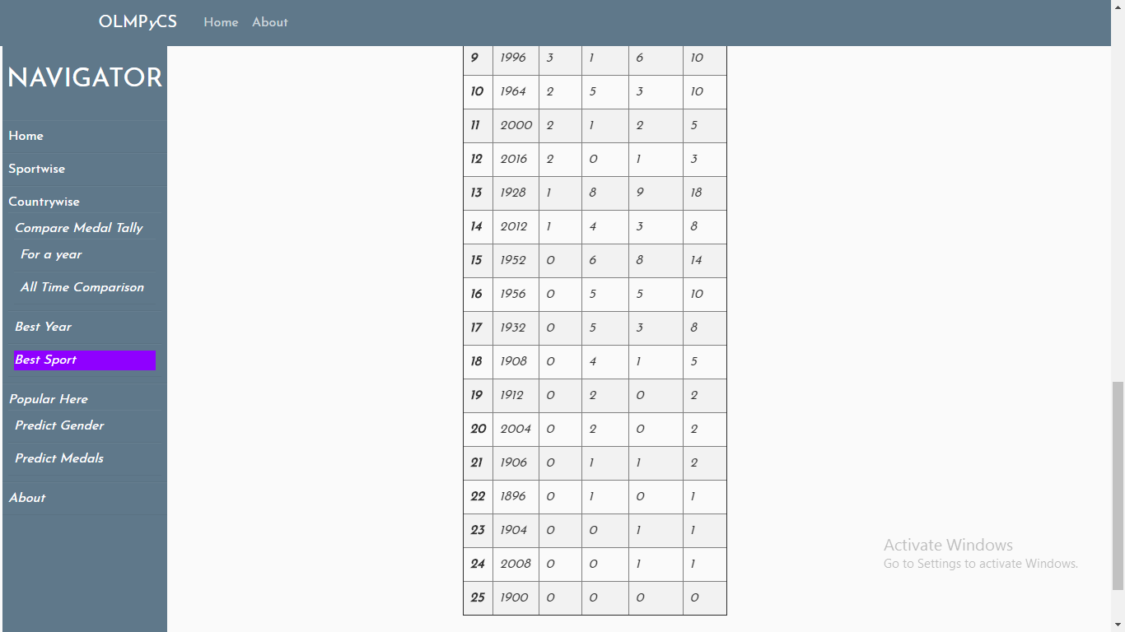

Gender prediction result :
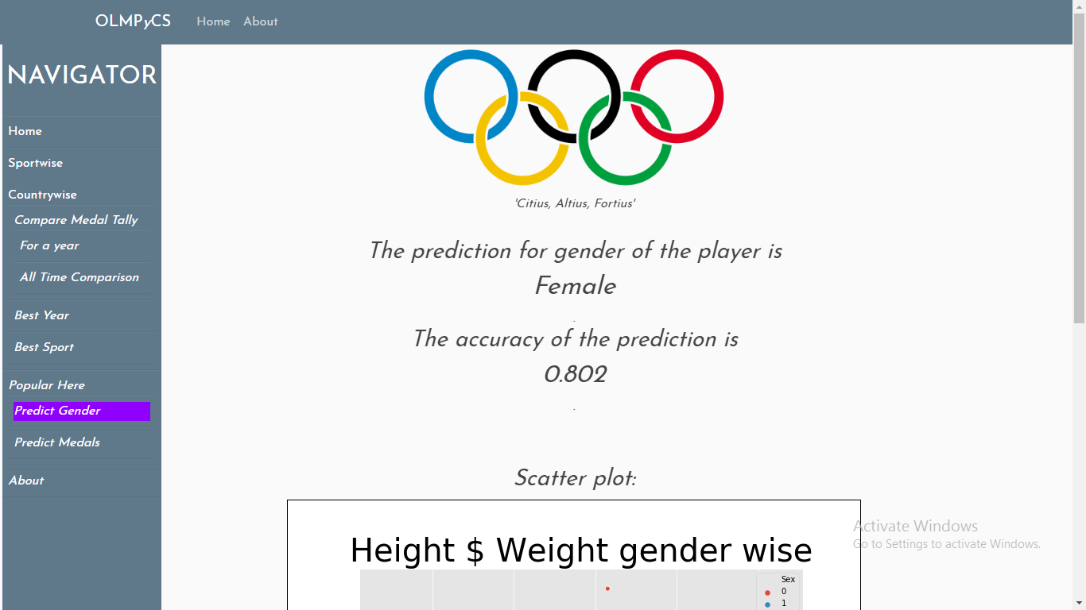

The Green point of the graph represents our input value:
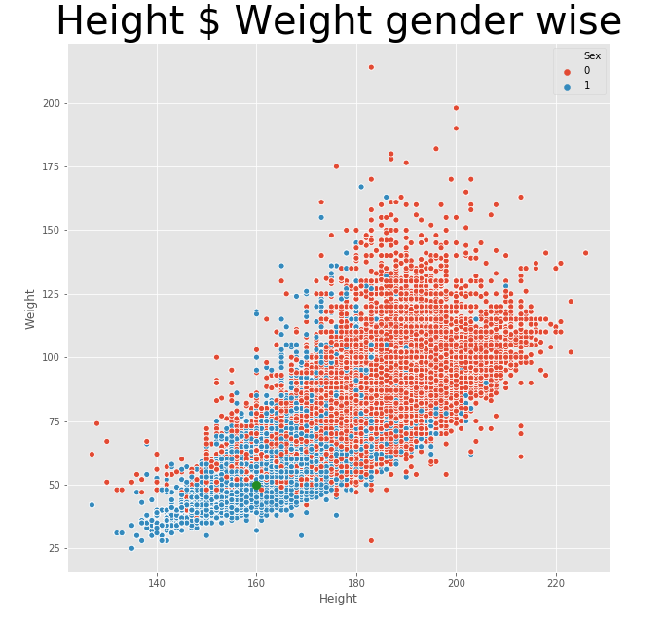

Prediction for medal count :
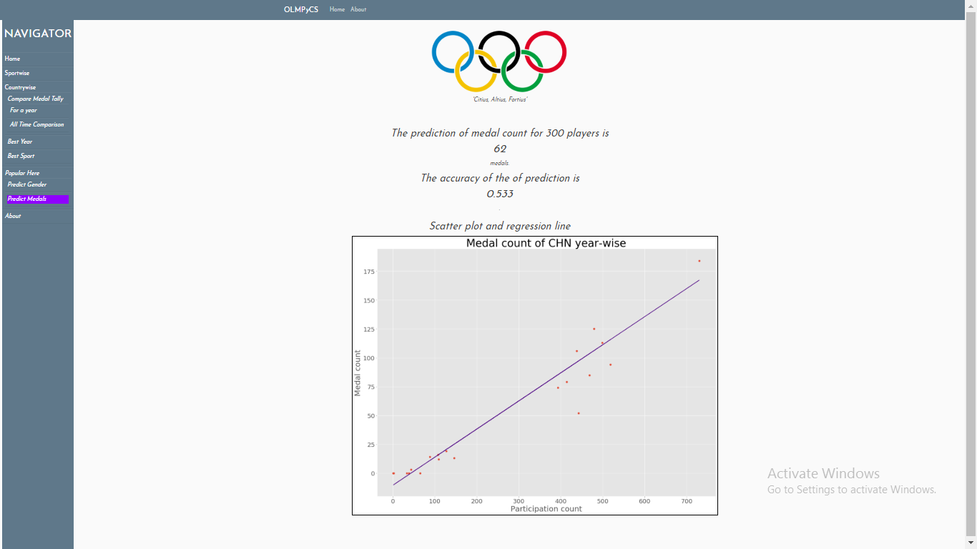
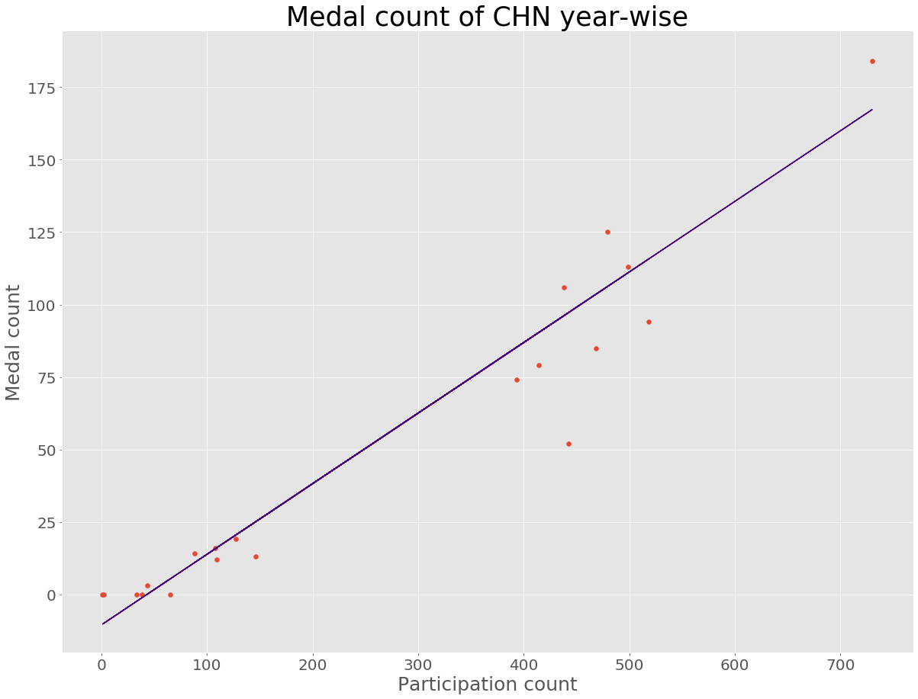

Most accomplished players in Olympics :
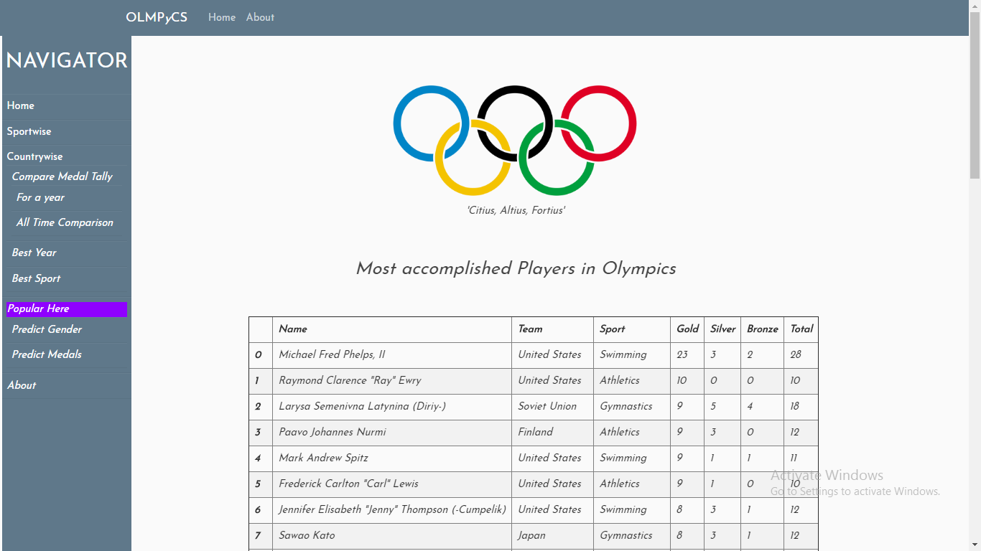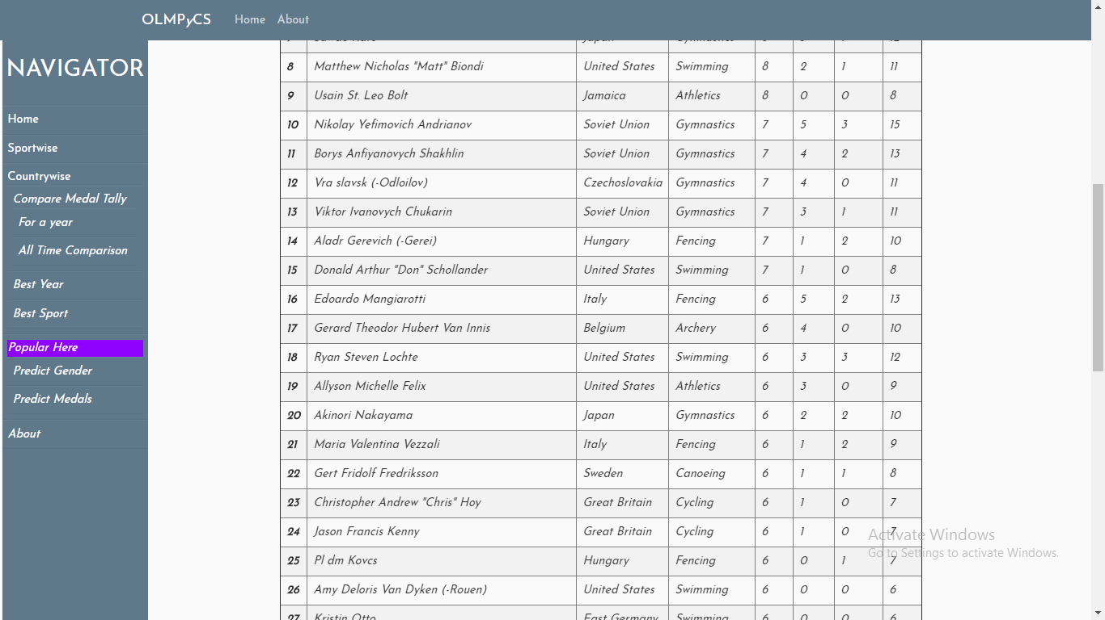

New sports introduction in Olympics :

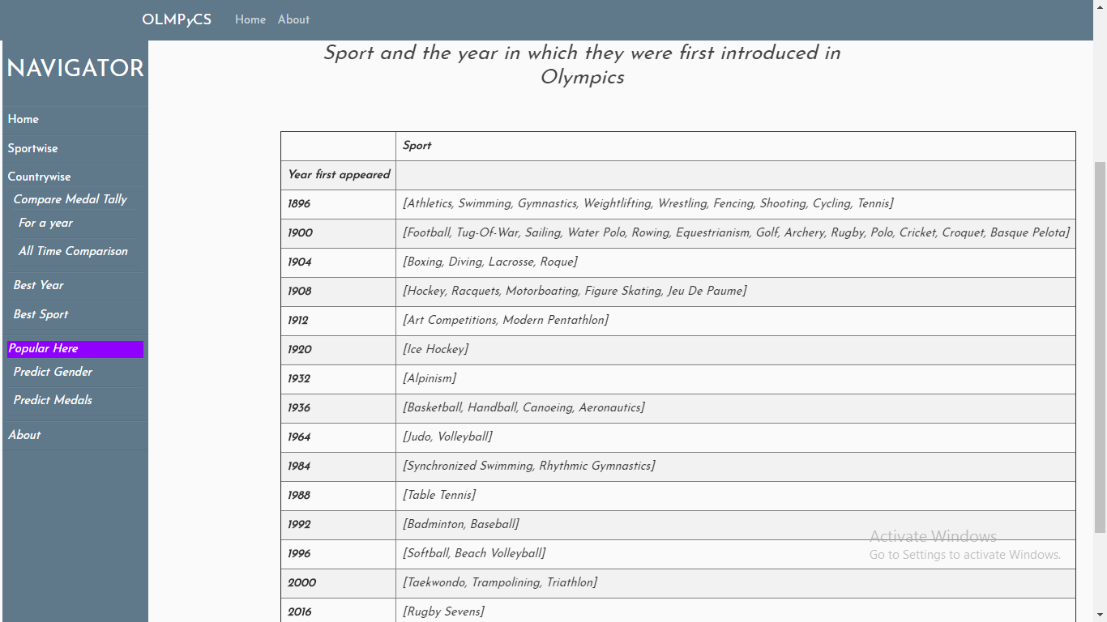

CONCLUSION

Analysis of records gives us an idea about the strength of different countries in
different sports they play.
The transition and changes in performance of different countries can be noticed
across late 19th, 20th and early 21st centuries.
Though the chances of winning medals depend on a lot of factors, but it is also
noticed that previous records do tend to affect the probability of winning the medal.

MINI PROJECT WRITE - UPS
DATASET

Title of Dataset: 120 years of olympic history
Domain of Dataset: Public
Source of Dataset: www.kaggle.com/heesoo37/120-years-of-olympic-history-athletes-and-results
No. of files: 2, athelete_events.csv and noc_regions.csv
No. of attributes: 15+3
Names and types of attributes:
- ID - Unique number for each athlete
- Name - Athlete's name
- Sex - M or F
- Age - Integer
- Height - In centimeters
- Weight - In kilograms
- Team - Team name
- NOC - National Olympic Committee 3-letter code
- Games - Year and season
- Year - Integer
- Season - Summer or Winter
- City - Host city
- Sport - Sport
- Event - Event
- Medal - Gold, Silver, Bronze, or NA
No. of records: 271117
Subjects under study: Performance of athletes and countries in Olympics
Expected Outcome: Results on countrywise, sportwise analysis of the dataset and prediction of medals and gender.

Attributes under consideration:
- Sex - M or F
- Age - Integer
- Height - In centimeters
- Weight - In kilograms
- Team - Team name
- NOC - National Olympic Committee 3-letter code
- Games - Year and season
- Year - Integer
- Sport - Sport
- Event - Event
- Medal - Gold, Silver, Bronze, or NA

ML ALGORITHMS

Linear Regression:

Category: Supervised Learning
Algorithm: Predicting medal count for a country depending the number of players sent for participation.

  - Take the number of participants and name of the country as the input to determine the number of medals a selected country will win.
  - Select only those rows in which the name of the country is same as selected country.
  - Group the data on the basis of year.
  - We have assigned the feature set (X) of the prediction algorithm as data frame’s ID columns.
  - And the label (y) is going to be Medal column.
  - Now, we have used sckit learn’s (sklearn) supervised algorithm LINEAR REGRESSION to predict our result.
  - The classifier is trained first using sklearn.model_selection.train_test_split() .
  - To fit the data on training data, we use LinearRegression.fit() .
  - In the end, to predict the result LinearRegression.predict() was used.
  - The data is graphed using matplotlib’s scatter plot to known values and the regression is plotted too.

Accuracy: 50 – 90% (Depends on data for different countries)

Decision Tree Classifier :

Category : Supervised Learning
Algorithm :Predicting gender of the player based on height, weight and age.

  - Take age, height and weight of player whose gender you want to predict.
  - We have assigned the feature set (X) of the prediction algorithm as data frame’s Age, Height , Weight columns.
  - And the label (y) is going to be Sex column.
  - Now, we have used sckit learn’s (sklearn) supervised algorithm DECISION TREE CLASSIFIER to predict our result.
  - The classifier is trained first using sklearn.model_selection.train_test_split() .
  - To fit the data on training data, we use DecisionTreeClassifier.fit() .
  - In the end, to predict the result DecisionTreeClassifier.predict() was used.
  - We have graphed the result using seaborn’s scatter plot and the predicted point is highlighted using green point on the graph.

Accuracy : 75 – 90%

FUNCTIONS

S.NO | FUNCTION NAME | SYNTAX | MODULE | DESCRIPTION
1. | load() | Pickle.load(filename) | Pickle | The primary argument of pickle load function is the file object that you get by opening the file in read-binary (rb) mode.
2. | unique() | Series.unique() | Pandas | Numpy array of unique values in that column.
3. | reset_index() | DataFrame.reset_index(level=None, drop=False, inplace=False, col_level=0, col_fill=”) | Pandas | reset_index() is a method to reset index of a Data Frame. reset_index() method sets a list of integer ranging from 0 to length of data as index.
4. | Groupby() | DataFrame.groupby(by=None, axis=0, level=None, as_index=True, sort=True, group_keys=True, squeeze=False, **kwargs) | Pandas | Groupby() function is used to split the data into groups based on some criteria. pandas objects can be split on any of their axes. The abstract definition of grouping is to provide a mapping of labels to group names.
5. | render_template() | flask.render_template(template_name_or_list, **context) | Flask | a HTML file can be rendered by the render_template() function.
6. | Redirect() | Flask.redirect(location, statuscode, response) | Flask | it returns a response object and redirects the user to another target location with specified status code.
7. | sort_values() | DataFrame.sort_values(by, axis=0, ascending=True, inplace=False, kind=’quicksort’, na_position=’last’) | Pandas | Pandas sort_values() function sorts a data frame in Ascending or Descending order of passed Column. It’s different than the sorted Python function since it cannot sort a data frame and particular column cannot be selected
8. | Append() | list.append(elmnt) |  | The append() method appends a passed obj into the existing list.
9. | DecisionTreeClassifier() | Tree.DecisionTreeClassifier() | Sklearn | A decision tree is a flowchart-like tree structure where an internal node represents feature(or attribute), the branch represents a decision rule, and each leaf node represents the outcome. The topmost node in a decision tree is known as the root node.
10. | Round() | round(number, number of digits) |  | rounds off to the given number of digits and returns the floating point number, if no number of digits is provided for round off , it rounds off the number to the nearest integer.
11. | Scatter() | matplotlib.pyplot.scatter(x,y,s=None,c=None,marker=None,cmap=None,norm=None) | Matplotlib | A scatter plot is a type of plot that shows the data as a collection of points. The position of a point depends on its two-dimensional value, where each value is a position on either the horizontal or vertical dimension
12. | Savefig() | savefig(fname, dpi=None, facecolor='w', edgecolor='w', orientation='portrait', papertype=None, format=None) | Matplotlib | we can opt to output the chart to a file instead of displaying it (or both if desired), by using the .savefig()method.
13. | read_csv() | pd.read_csv(filepath_or_buffer, sep=’, ‘, delimiter=None, header=’infer’, names=None, index_col=None, usecols=None, squeeze=False, prefix=None, mangle_dupe_cols=True,) | Pandas | Reads csv file
14. | Merge() | DataFrame.merge(self,right,how='inner',on=None,left_on=None,right_on=None,left_index=False,right_index=False,sort=False,suffixes=('_x','_y'),copy=True,indicator=False,validate=None) | Pandas | The join is done on columns or indexes. If joining columns on columns, the DataFrame indexes will be ignored. Otherwise if joining indexes on indexes or indexes on a column or columns, the index will be passed on.
15. | Sum() | sum(iterable, start) |  | Gives sum of elements in the list.
16. | Bar() | matplotlib.pyplot.bar(x,height,width=0.8,bottom=None,*,align='center',data=None,**kwargs) | Matplotlib | Plots bar graph.
17. | Figure() | matplotlib.pyplot.figure(num=None,figsize=None,dpi=None,facecolor=None,edgecolor=None, | Matplotlib | The purpose of using plt.figure() is to create a figure object. The whole figure is regarded as the figure object. It is necessary to explicitly use plt.figure() when we want to tweak the size of the figure and when we want to add multiple Axes objects in a single figure.
18. | Array() | numpy.array(object,dtype=None,copy=True,order='K',subok=False,ndmin=0) | Numpy | Creates array of given elements.

